11-2-2019

UPZMG

Parámetros DH y TH

Cinemática de Robots

Jesús Jail Avalos Lupercio.

Ing. Mecatrónica 8º A

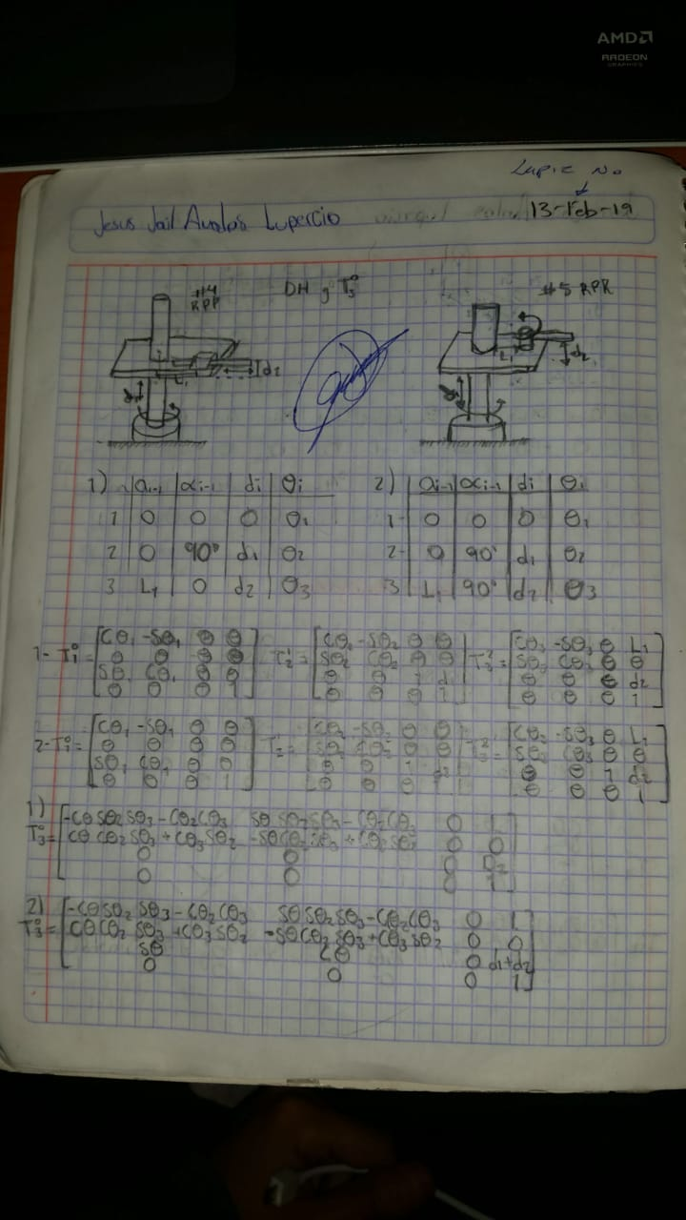

|  |  |  |  |  |
| --- | --- | --- | --- | --- |
| Eslabón | $$A_{i-1}$$ | $$α_{i-1}$$ | d $i$ | $$θi$$ |
| 1 | 0 | 0 | 0 | $$θ_{1}$$ |
| 2 | 0 | 90º | $$d_{1}$$ | $$θ_{2}$$ |
| 3 | $$L_{1}$$ | 0 |  |  |

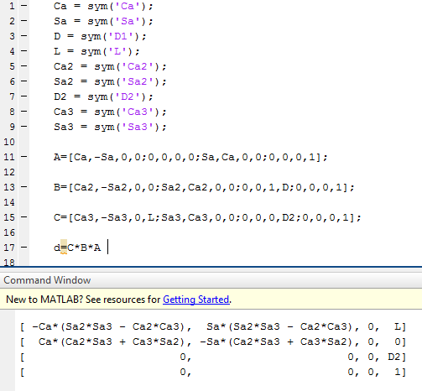



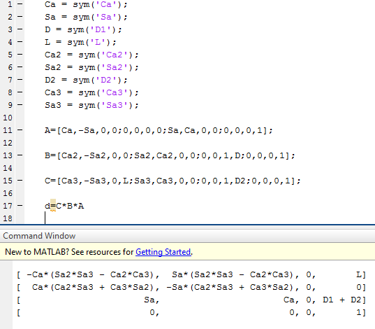

|  |  |  |  |  |
| --- | --- | --- | --- | --- |
| Eslabón | $$A_{i-1}$$ | $$α_{i-1}$$ | d $i$ | $$θi$$ |
| 1 | 0 | 0 | 0 | $$θ_{1}$$ |
| 2 | 0 | 90º | $$d_{1}$$ | $$θ_{2}$$ |
| 3 | $$L_{1}$$ | 90º | $$d_{2}$$ | $$θ_{3}$$ |